**Assignment 07**

**KD1-Indrajeet-86641**

Q1. Write a query that counts all orders for October 3.

🡺 **select count(*) from orders where odate = ‘1990-10-03’;**

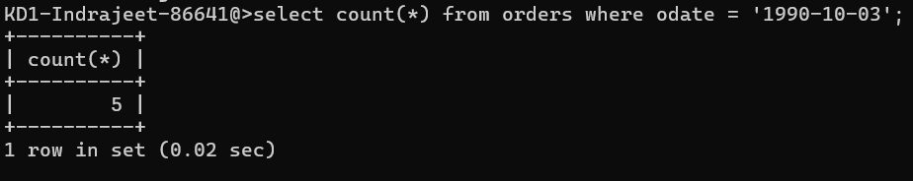

Q2. Write a query that counts the number of different non-NULL city values in the Customers table.

🡺 **select count(*) from customers where city != null;**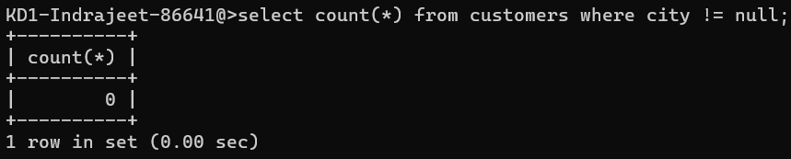

Q3. Write a query that selects each customer’s smallest order.

🡺 **select cnum, min(amt) from orders group by cnum;**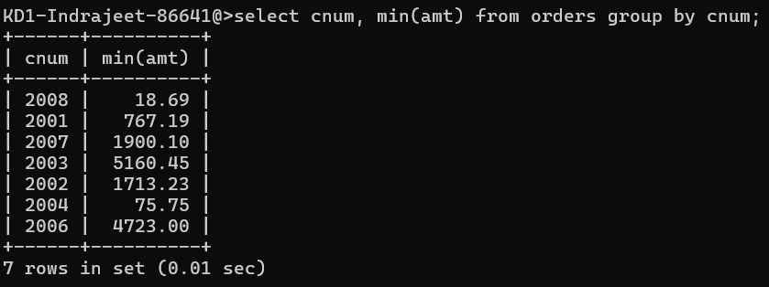

Q4. Write a query that selects the first customer, in alphabetical order, whose name begins with G.

🡺 **select * from customers where cname like ‘G%’ limit 1;**

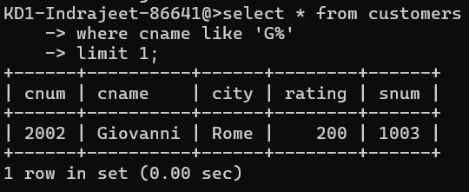

Q5. Write a query that selects the highest rating in each city.

🡺 **select city, max(rating) from customers group by city;**

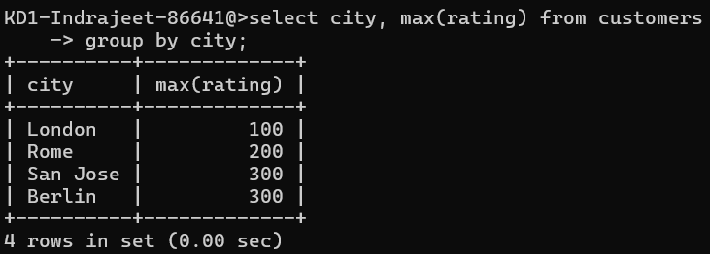

Q6. Write a query that counts the number of salespeople registering orders for each day. (If a salesperson has more than one order on a given day, he or she should be counted only once).

🡺 **select count(distinct snum) from orders group by odate;**

